Project Proposal
Team Members
Caitlin Uang (caitlin.uang@baruchmail.cuny.edu)
Su Wai (su.wai@baruchmail.cuny.edu)
Hui Gao (hui.gao1@baruchmail.cuny.edu)
Qiaoping Wang (qiaoping.wang@baruchmail.cuny.edu)
Nino Aliashvili (nino.aliashvili@baruchmail.cuny.edu)

Project Title: Music Festival Management System
Course: CIS 9340 UTA [38337]
Group #1

Introduction
Music festivals involve thousands of attendees, artists, vendors, sponsors, and logistical staff. Without a centralized system, event organizers face challenges such as scheduling conflicts, disorganized ticketing, difficulty tracking vendor and merchandise sales, and limited visibility into operations.
The Music Festival Management System addresses these issues by consolidating event operations into a coordinated relational database. The proposed system supports: Scheduling artists and performances across multiple stages, Tracking attendees, ticket types, and check-in, Recording merchandise and vendor sales, Managing artist accommodations and transportation, Documenting security incidents and Managing sponsorship agreements. This system allows festival organizers to make data driven decisions, avoid resource conflicts, and streamline operations.
In this project, our group designed and implemented a relational database to support the Music Festival Management System. The work included developing an Entity Relationship Diagram (ERD), converting the conceptual model into a relational data model, identifying functional dependencies, and normalizing the relations to Third Normal Form and, where applicable, Boyce-Codd Normal Form. We then implemented the database using SQL, including the creation of tables, primary key and foreign key constraints, and sample data. Finally we developed several application scenarios using SQL queries to demonstrate how the system can support real operational and managerial needs of a music festival.

Entity Relationship Model (ERD)
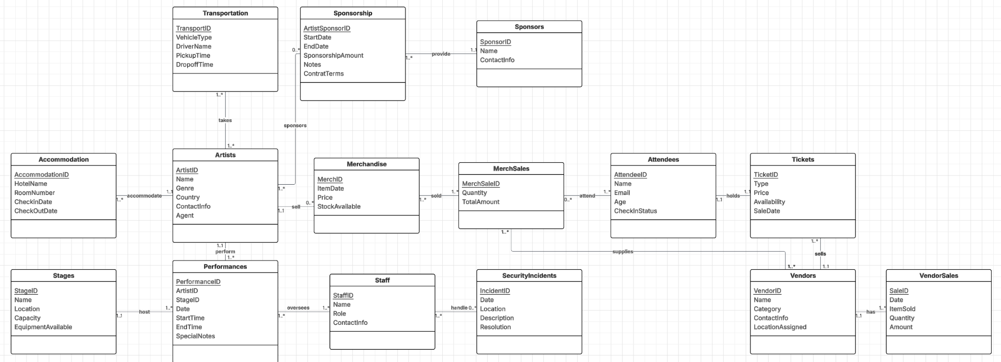

Relationship Sentences
One artist may sell many merchandise.
One merchandise must be sold by one artist.

One MerchSale must sell one or more merchandise.
One Merchandise can be sold in one or more MerchSale.

One Attendee may attend many MerchSale.
One MerchSale may have many Attendees.

One Attendee can only hold one ticket.
One ticket is assigned to one attendee.

One Vendor may sell many tickets.
One ticket must be sold by one vendor.

One Vendor may have many vendorsales.
One Vendorsales must be for one vendor.

One MerchSale is supplied by many vendor.
One vendor may supply many merchsales.

One artist may take one or more transportation.
One transportation must be for one or more artist.

One sponsorship may have sponsored many artists
One artist may have one or more sponsorship.

One sponsor may provide many sponsorships.
One sponsorship must be provided by one sponsor.

One artist may perform many performances.
One performance must be performed by one artist.

One stage can host many performances.
One performance must be on one stage.

One staff may oversee one or more performances.
One performance must be overseen by many staff.

One staff may handle many security incidents.
One security incident may be handled by many staff.

One accommodation may host one or more artist.
One artist must be accommodated by one accommodation.

RDM and Normalization

Relational Data Model
Artists(ArtistID, Name, Genre, Country, ContactInfo, Agent)
Merchandise(MerchID, ItemDate, Price, StockAvailable, ArtistID(fk))
MerchSales (MerchSaleID, Quantity, TotalAmount)
Merchandise_MerchSales(MerchID, MerchSaleID)

Attendees(AttendeeID, Name, Email, Age, CheckInStatus)
MerchSales_Attendees(MerchSaleID, AttendeeID)
Attendees_Tickets(AttendeeID, TicketID ,Type, Price, Availability, SaleDate)
Tickets(TicketID, Type, Price, Availability, SaleDate, VendorID(fk))

Vendors(VendorID, Name, Category, ContactInfo, LocationAssigned)
VendorSales(SaleID, Date, ItemSold, Quantity, Amount, VendorID(fk))
Vendors_MerchSales(VendorID, MerchSaleID)

Transportation(TransportID, VehicleType, DriverName, PickupTime, DropoffTime)
Artists_Transportation(ArtistID, TransportID)

Sponsorship(ArtistSponsorID, StartDate, EndDate, SponsorshipAmount, Notes, ContractTerms, SponsorID(fk))
Sponsors(SponsorID, Name, ContactInfo)
Artists_Sponsorship(ArtistID, ArtistSponsorID)

Performances(PerformanceID, Date, StartTime, EndTime, SpecialNotes, ArtistID(fk), StageID(fk))
Stages(StageID, Name, Location, Capacity, EquipmentAvailable)

Staff(StaffID, Name, Role, ContactInfo)
Performances_Staff(PerformanceID, StaffID)
SecurityIncidents(IncidentID, Date, Location, Description, Resolution)
Staff_SecurityIncidents(StaffID, IncidentID)

Accommodation(AccommodationID, HotelName, RoomNumber, CheckinDate, CheckoutDate, ArtistID(fk))

Normalization
Artists(ArtistID, Name, Genre, Country, ContactInfo, Agent)
● Key: ArtistID
○ FD1: ArtistID → Name, Genre, Country, ContactInfo, Agent
○ FD2: Agent → ContactInfo
● 1NF: Meets the definition of a relation
● 2NF: No partial Key dependencies
● 3NF: Transitive dependency exists: ArtistID -> Agent and Agent -> ContactInfo
○ Artists(ArtistID, Name, Genre, Country, Agent)
○ Agents(Agent, ContactInfo)
● 1NF: Meets the definition of a relation
● 2NF: No partial Key dependencies
● 3NF: No Transitive dependencies
● BCNF: Violates BCNF
○ Artists(ArtistID, Name, Genre, Country)
○ Agents(Agent, ContactInfo)

Merchandise(MerchID, ItemDate, Price, StockAvailable, ArtistID)
● Key: MerchID
○ FD1: MerchID → ItemDate, Price, StockAvailable, ArtistID
○ FD2: ArtistID → Name, Genre, Country, Agent
● 1NF: Meets the definition of a relation
● 2NF: No partial key dependencies
● 3NF: No transitive dependencies - ArtistID is foreign key
● BCNF: every determinant is a candidate key
○ Merchandise(MerchID, ItemDate, Price, StockAvailable, ArtistID)

MerchSales(MerchSaleID, Quantity, TotalAmount)
● Key: MerchSaleID
○ FD1: MerchSaleID → Quantity, TotalAmount
● 1NF: Meets the definition of a relation
● 2NF: No partial key dependencies
● 3NF: No transitive dependencies
● BCNF: every determinant is a candidate key
○ MerchSales(MerchSaleID, Quantity, TotalAmount)

Merchandise_MerchSales(MerchID, MerchSaleID)
● Key: (MerchID, MerchSaleID)
○ FD1: (MerchID, MerchSaleID)
● 1NF: Meets the definition of a relation
● 2NF: No partial key dependencies
● 3NF: No transitive dependencies
● BCNF: every determinant is a candidate key
○ Merchandise_MerchSales(MerchID, MerchSaleID)

Attendees(AttendeeID, Name, Email, Age, CheckInStatus)
● Key: AttendeeID
○ FD1: AttendeeID → Name, Email, Age, CheckInStatus
● 1NF: Meets the definition of a relation
● 2NF: No partial key dependencies
● 3NF: No transitive dependencies
● BCNF: every determinant is a candidate key
○ Attendees(AttendeeID, Name, Email, Age, CheckInStatus)

MerchSales_Attendees(MerchSaleID, AttendeeID)
● Key: (MerchSaleID, AttendeeID)
○ FD1: (MerchSaleID, AttendeeID)
● 1NF: Meets the definition of a relation
● 2NF: No partial key dependencies
● 3NF: No transitive dependencies
● BCNF: every determinant is a candidate key
○ MerchSales_Attendees(MerchSaleID, AttendeeID)

Attendees_Tickets(AttendeeID,Name, Email, Age, CheckInStatus, TicketID,Type, Price, Availability, SaleDate)
● Key: (AttendeeID, TicketID)
○ FD1: (AttendeeID, TicketID) → Name, Email, Age, CheckInStatus,Type, Price, Availability, SaleDate
○ FD2: AttendeeID → Name, Email, Age, CheckInStatus
○ FD3: TicketID → Type, Price, Availability, SaleDate
● 1NF: Meets the definition of a relation
● 2NF: there is partial key dependencies
○ Attendees(AttendeeID, Name, Email, Age, CheckInStatus)
○ Tickets(TicketID, Type, Price, Availability, SaleDate)
○ Attendees_Tickets(AttendeeID, TicketID)
● 1NF: Meets the definition of a relation
● 2NF: No partial key dependencies
● 3NF: No transitive dependencies
● BCNF: every determinant is a candidate key
○ Attendees(AttendeeID, Name, Email, Age, CheckInStatus)
○ Tickets(TicketID, Type, Price, Availability, SaleDate)
○ Attendees_Tickets(AttendeeID, TicketID)

Tickets(TicketID, Type, Price, Availability, SaleDate, VendorID(fk))
● Key: TicketID
○ FD1: TicketID → Type, Price, Availability, SaleDate, VendorID(fk)
○ FD2: VendorID → Name, Category, ContactInfo, LocationAssigned
● 1NF: Meets the definition of a relation
● 2NF: No partial key dependencies
● 3NF: No transitive dependencies - VendorID is a foreign key
● BCNF: every determinant is a candidate key
○ Tickets(TicketID, Type, Price, Availability, SaleDate, VendorID)

Vendors(VendorID, Name, Category, ContactInfo, LocationAssigned)
● Key: VendorID
○ FD1: VendorID → Name, Category, ContactInfo, LocationAssigned
○ FD2: Name → ContactInfo
● 1NF: Meets the definition of a relation
● 2NF: No partial key dependencies
● 3NF: Transitive dependency exists
○ Vendors(VendorID, Name, Category, ContactInfo, LocationAssigned)
○ VendorName(Name, ContactInfo)
● 1NF: Meets the definition of a relation
● 2NF: No partial Key dependencies
● 3NF: No Transitive dependencies
● BCNF: Violates BCNF
○ Vendors(VendorID, Name, Category, LocationAssigned)
○ VendorName(Name, ContactInfo)

VendorSales(SaleID, Date, ItemSold, Quantity, Amount, VendorID(fk))
● Key: SaleID
○ FD1: SaleID → Date, ItemSold, Quantity, Amount, VendorID
○ FD2: VendorID → Name, Category, ContactInfo, LocationAssigned
● 1NF: Meets the definition of a relation
● 2NF: No partial key dependencies
● 3NF: No transitive dependencies - VendorID is a foreign key
● BCNF: every determinant is a candidate key
○ VendorSales(SaleID, Date, ItemSold, Quantity, Amount, VendorID)

Transportation(TransportID, VehicleType, DriverName, PickupTime, DropoffTime)
● Key: TransportID
○ FD1: TransportID → VehicleType, DriverName, PickupTime, DropoffTime
● 1NF: Meets the definition of a relation
● 2NF: No partial key dependencies
● 3NF: No transitive dependencies
● BCNF: every determinant is a candidate key
○ Transportation(TransportID, VehicleType, DriverName, PickupTime, DropoffTime)

Performances(PerformanceID, Date, StartTime, EndTime, SpecialNotes, ArtistID(fk), StageID(fk))
● Key: PerformanceID
○ FD1: PerformanceID → Date, StartTime, EndTime, SpecialNotes, ArtistID, StageID
○ FD2: ArtistID → Name, Genre, Country, ContactInfo, Agent
○ FD3: StageID → Name, Location, Capacity, EquipmentAvailable
● 1NF: Meets the definition of a relation
● 2NF: No partial key dependencies
● 3NF: No transitive dependencies - ArtistID and StageD are foreign keys
● BCNF: every determinant is a candidate key
○ Performances(PerformanceID, Date, StartTime, EndTime, SpecialNotes, ArtistID(fk), StageID(fk))

Stages(StageID, Name, Location, Capacity, EquipmentAvailable)
● Key: StageID
○ FD1: StageID → Name, Location, Capacity, EquipmentAvailable
○ FD2: Location → Capacity, EquipmentAvailable
● 1NF: Meets the definition of a relation
● 2NF: No partial Key dependencies
● 3NF: Transitive dependency exists: Location → Capacity, EquipmentAvailable
○ Stage(StageID, Name, Location)
○ Locations(Location, Capacity, EquipmentAvailable)
● 1NF: Meets the definition of a relation
● 2NF: No partial Key dependencies
● 3NF: No Transitive dependencies
● BCNF: Violates BCNF
○ Stage(StageID, Name)
○ Locations(Location, Capacity, EquipmentAvailable)

Sponsorship(ArtistSponsorID, StartDate, EndDate, SponsorshipAmount, Notes, ContractTerms, SponsorID(fk))
● Key: ArtistSponsorID
○ FD1: ArtistSponsorID → StartDate, EndDate, SponsorshipAmount, Notes, ContractTerms, SponsorID(fk))
○ FD2: SponsorID → Name, ContactInfo
● 1NF: Meets the definition of a relation
● 2NF: No partial key dependencies
● 3NF: No transitive dependencies - SponsorID is a foreign key
● BCNF: every determinant is a candidate key
○ Sponsorship(ArtistSponsorID, StartDate, EndDate, SponsorshipAmount, Notes, ContractTerms, SponsorID(fk))

Sponsors(SponsorID, Name, ContactInfo)
● Key: SponsorID
○ FD1: SponsorID → Name, ContactInfo
○ FD2: Name → ContactInfo
● 1NF: Meets the definition of a relation
● 2NF: No partial key dependencies
● 3NF: Transitive dependency exists
○ Sponsors(SponsorID, Name, ContactInfo)
○ SponsorNames(Name, ContactInfo)
● BCNF: Violates BCNF
○ Sponsors(SponsorID, Name)
○ SponsorNames(Name, ContactInfo)

Staff(StaffID, Name, Role, ContactInfo)
● Key: StaffID
○ FD1: StaffID → Name, Role, Contact Info
○ FD2: Name → Contact Info
● 1NF: Meets the definition of a relation
● 2NF: No partial key dependencies
● 3NF: Transitive dependency exists
○ Staff(StaffID, Name, Role, ContactInfo)
○ StaffNames(Name, Role, ContactInfo)
● BCNF: Violates BCNF
○ Staff(StaffID, Name)
○ StaffNames(Name, Role, ContactInfo)

SecurityIncidents(IncidentID, Date, Location, Description, Resolution)
● Key: IncidentID
○ FD1: IncidentID → Date, Location, Description, Resolution
● 1NF: Meets the definition of a relation
● 2NF: No partial key dependencies
● 3NF: No transitive dependencies
● BCNF: every determinant is a candidate key
○ SecurityIncidents(IncidentID, Date, Location, Description, Resolution)

Accommodation(AccommodationID, HotelName, RoomNumber, CheckinDate, CheckoutDate, ArtistID(fk))
● Key: AccomodationID
○ FD1: AccommodationID → HotelName, RoomNumber, CheckinDate, CheckoutDate, ArtistID(fk)
○ FD2: HotelName, RoomNumber → CheckinDate, CheckoutDate
● 1NF: Meets the definition of a relation
● 2NF: No partial key dependencies
● 3NF: Transitive dependency exists
○ Accommodation(AccommodationID, HotelName, RoomNumber, CheckinDate, CheckoutDate, ArtistID)
○ HotelRooms(HotelName, RoomNumber, CheckinDate, CheckoutDate)
● BCNF: Violates BCNF
○ Accommodation(AccommodationID, HotelName, RoomNumber, ArtistID)
○ HotelRooms(HotelName, RoomNumber, CheckinDate, CheckoutDate)

All Normalized Relations
Artists(ArtistID, Name, Genre, Country)
Agents(Agent, ContactInfo)

Merchandise(MerchID, ItemDate, Price, StockAvailable, ArtistID)
MerchSales(MerchSaleID, Quantity, TotalAmount)
Merchandise_MerchSales(MerchID, MerchSaleID)

Attendees(AttendeeID, Name, Email, Age, CheckInStatus)
Tickets(TicketID, Type, Price, Availability, SaleDate, VendorID)
Attendees_Tickets(AttendeeID, TicketID)

Vendors(VendorID, Name, Category, LocationAssigned)
VendorName(Name, ContactInfo)
VendorSales(SaleID, Date, ItemSold, Quantity, Amount, VendorID)
Vendors_MerchSales(VendorID, MerchSaleID)

Transportation(TransportID, VehicleType, DriverName, PickupTime, DropoffTime)
Artists_Transportation(ArtistID, TransportID)

Performances(PerformanceID, Date, StartTime, EndTime, SpecialNotes, ArtistID, StageID)
Stage(StageID, Name)
Locations(Location, Capacity, EquipmentAvailable)

Sponsorship(ArtistSponsorID, StartDate, EndDate, SponsorshipAmount, Notes, ContractTerms, SponsorID)
Sponsors(SponsorID, Name)
SponsorNames(Name, ContactInfo)
Artists_Sponsorship(ArtistID, ArtistSponsorID)

Staff(StaffID, Name)
StaffNames(Name, Role, ContactInfo)
Performances_Staff(PerformanceID, StaffID)

SecurityIncidents(IncidentID, Date, Location, Description, Resolution)
Staff_SecurityIncidents(StaffID, IncidentID)

Accommodation(AccommodationID, HotelName, RoomNumber, ArtistID)
HotelRooms(HotelName, RoomNumber, CheckinDate, CheckoutDate)

Based on the Entity Relationship Model, the database was converted into a collection of relational tables. For each relation, functional dependencies were identified in order to guide the normalization process and ensure data integrity. The goal of normalization was to reduce redundancy, eliminate update anomalies, and maintain logical consistency across the database.
Each relation was first evaluated to ensure it satisfied First Normal Form (1NF) by containing only atomic attributes and no repeating groups. All tables met this requirement.Next, the relations were examined for Second Normal Form (2NF). Tables with composite primary keys were analyzed to ensure that all non-key attributes were fully functionally dependent on the entire key. When we identified partial dependencies, we decomposed the relations into smaller tables. For example, the original Attendees_Tickets relation was decomposed into separate Attendees, Tickets, and Attendees_Tickets tables to remove partial dependencies.
The relations were then normalized to Third Normal Form (3NF) by eliminating transitive dependencies. In several cases, attributes that depended on non-key attributes were moved into separate relations. For instance, vendor contact information, sponsor contact information, staff contact information, and stage location details were separated into distinct tables to remove transitive dependencies and improve data integrity.
We further evaluated against Boyce-Codd Normal Form (BCNF) where it was possible. Some relations violated BCNF due to business rules where non-key attributes determined other non-key attributes. In such cases, the relations were decomposed to satisfy BCNF whenever it did not negatively impact usability or clarity.
Although the database design was normalized to Third Normal Form and, where appropriate to BCNF, some tables were implemented in a slightly denormalized form in the SQL database. This was done intentionally to simplify queries, reduce the number of joins, and improve usability for the application. For example, some descriptive attributes were kept within core tables rather than separated into additional lookup tables, and certain associative tables include extra attributes to support clearer reporting. These choices preserve data integrity through enforced primary and foreign key constraints while balancing theoretical design with practical database use.
Data Application

- Creating the Database with SQL
CREATE TABLE Artists(
ArtistID NUMBER NOT NULL,
Name VARCHAR(20),
Genre VARCHAR(20),
Country VARCHAR(20),
ContactInfo VARCHAR(20),
Agent VARCHAR(20),
CONSTRAINT pk_Artists PRIMARY KEY (ArtistID))

CREATE TABLE Merchandise(
MerchID NUMBER NOT NULL,
ItemDate DATE,
Price NUMBER NOT NULL,
StockAvailable VARCHAR(20),
CONSTRAINT pk_Merchandise PRIMARY KEY (MerchID))

CREATE TABLE MerchSales(
MerchSaleID NUMBER NOT NULL,
Quantity NUMBER NOT NULL,
TotalAmount NUMBER NOT NULL,
CONSTRAINT pk_MerchSales PRIMARY KEY (MerchSaleID)
)

CREATE TABLE Merchandise_MerchSales(
MerchID NUMBER NOT NULL,
MerchSaleID NUMBER NOT NULL,
CONSTRAINT pk_Merchandise_MerchSales PRIMARY KEY (MerchID, MerchSaleID)
)

CREATE TABLE Attendees(
AttendeeID NUMBER NOT NULL,
Name VARCHAR(20),
Email VARCHAR(20),
Age NUMBER NOT NULL,
CheckInStatus VARCHAR(20),
CONSTRAINT pk_Attendees PRIMARY KEY (AttendeeID)
)
CREATE TABLE MerchSales_Attendees(
AttendeeID NUMBER NOT NULL,
MerchSaleID NUMBER NOT NULL,
CONSTRAINT pk_MerchSales_Attendees PRIMARY KEY (AttendeeID,MerchSaleID)
)

CREATE TABLE Attendees_Tickets(
AttendeeID NUMBER NOT NULL,
Name VARCHAR(20),
Email VARCHAR(20),
Age NUMBER NOT NULL,
CheckInStatus VARCHAR(20),
TicketID NUMBER NOT NULL,
Type VARCHAR(20),
Price NUMBER NOT NULL,
Availability VARCHAR(20),
SaleDate DATE,
CONSTRAINT pk_Attendees_Tickets PRIMARY KEY (AttendeeID)
)

CREATE TABLE Tickets(
TicketID NUMBER NOT NULL,
Type VARCHAR(20),
Price NUMBER NOT NULL,
Availability VARCHAR(20),
SaleDate DATE,
VendorID NUMBER NOT NULL,
CONSTRAINT pk_Tickets PRIMARY KEY (TicketID))

CREATE TABLE Vendor(
VendorID NUMBER NOT NULL,
Name VARCHAR(20),
Category VARCHAR(20),
ContactInfo VARCHAR(20),
LocationAssigned VARCHAR(20),
CONSTRAINT pk_Vendor PRIMARY KEY (VendorID)
)

CREATE TABLE VendorSales(
SaleID NUMBER NOT NULL,
SaleDate DATETIME,
ItemSold VARCHAR(20),
Quantity NUMBER NOT NULL,
Amount NUMBER NOT NULL,
VendorID NUMBER NOT NULL,
CONSTRAINT pk_VendorSales PRIMARY KEY (SaleID))

CREATE TABLE Vendors_MerchSales(
VendorID NUMBER NOT NULL,
MerchSaleID NUMBER NOT NULL,
CONSTRAINT pk_Vendors_MerchSales PRIMARY KEY (VendorID, MerchSaleID)
)

CREATE TABLE Transportation(
TransportID NUMBER NOT NULL,
VehicleType VARCHAR(20),
DriverName VARCHAR(20),
PickupTime VARCHAR(20),
DropoffTime VARCHAR(20),
CONSTRAINT pk_Transportation PRIMARY KEY (TransportID)
)

CREATE TABLE Artists_Transportation(
TransportID NUMBER NOT NULL,
ArtistID NUMBER NOT NULL,
CONSTRAINT pk_Artists_Transportation PRIMARY KEY (VendorID,ArtistID)
)

CREATE TABLE Sponsors(
SponsorID NUMBER NOT NULL,
Name VARCHAR(20),
ContactInfo VARCHAR(20),
CONSTRAINT pk_Sponsors PRIMARY KEY (SponsorID)
)
CREATE TABLE Sponsorship(
ArtistSponsorID NUMBER NOT NULL,
StartDate DATE,
EndDate DATE,
SponsorshipAmount NUMBER NOT NULL,
Notes VARCHAR(20),
ContractTerms VARCHAR(20),
SponsorID NUMBER NOT NULL,
CONSTRAINT pk_Sponsorship PRIMARY KEY (ArtistSponsorID))

CREATE TABLE Artists_Sponsorship(
ArtistSponsorID NUMBER NOT NULL,
ArtistID NUMBER NOT NULL,
CONSTRAINT pk_Artists_Sponsorship PRIMARY KEY (ArtistSponsorID,ArtistID)
)

CREATE TABLE Stages(
StageID NUMBER NOT NULL,
Name VARCHAR(20),
Location VARCHAR(20),
Capacity VARCHAR(20),
EquipmentAvailable VARCHAR(20),
CONSTRAINT pk_Stages PRIMARY KEY (StageID)
)
CREATE TABLE Performances(
PerformanceID NUMBER NOT NULL,
PerformanceDate DATE,
StartTime VARCHAR(20),
EndTIme VARCHAR(20),
SpecialNotes VARCHAR(20),
ArtistID NUMBER NOT NULL,
StageID NUMBER NOT NULL,
CONSTRAINT pk_Performances PRIMARY KEY (PerformanceID))

CREATE TABLE Staff(
StaffID NUMBER NOT NULL,
Name VARCHAR(20),
Role VARCHAR(20),
ContactInfo VARCHAR(20),
CONSTRAINT pk_Staff PRIMARY KEY (StaffID)
)

CREATE TABLE Performances_Staff(
StaffID NUMBER NOT NULL,
PerformanceID NUMBER NOT NULL,
CONSTRAINT pk_Performances_Staff PRIMARY KEY (PerformanceID,StaffID))
CREATE TABLE SecurityIncidents(
IncidentID NUMBER NOT NULL,
SecurityDate DATE,
Location VARCHAR(20),
Description VARCHAR(20),
Resolution VARCHAR(20),
CONSTRAINT pk_SecurityIncidents PRIMARY KEY (IncidentID)
)

CREATE TABLE Staff_SecurityIncidents(
StaffID NUMBER NOT NULL,
IncidentID NUMBER NOT NULL,
CONSTRAINT pk_Staff_SecurityIncidents PRIMARY KEY (StaffID,IncidentID)
)

CREATE TABLE Accommodation(
AccommodationID NUMBER NOT NULL,
HotelName VARCHAR(20),
RoomNumber NUMBER,
CheckinDate DATE,
CheckoutDate DATE,
ArtistID NUMBER NOT NULL,
CONSTRAINT pk_Accommodation PRIMARY KEY (AccommodationID))

- Specifying foreign keys
ALTER TABLE Merchandise
ADD CONSTRAINT fk_Merchandise
FOREIGN KEY (ArtistID)
REFERENCES Artists(ArtistID)

ALTER TABLE Tickets
ADD CONSTRAINT fk_Tickets
FOREIGN KEY (VendorID)
REFERENCES Vendor(VendorID)

ALTER TABLE VendorSales
ADD CONSTRAINT fk_VendorSales
FOREIGN KEY (VendorID)
REFERENCES Vendor(VendorID)

ALTER TABLE Sponsorship
ADD CONSTRAINT fk_Sponsorship
FOREIGN KEY (SponsorID)
REFERENCES Sponsors(SponsorID)

ALTER TABLE Performances
ADD CONSTRAINT fk_Performances
FOREIGN KEY (ArtistID)
REFERENCES Artists(ArtistID)

ALTER TABLE Performances
ADD CONSTRAINT fk_Performances2
FOREIGN KEY (StageID)
REFERENCES Stages(StageID)

ALTER TABLE Accommodation
ADD CONSTRAINT fk_Accommodation
FOREIGN KEY (ArtistID)
REFERENCES Artists(ArtistID)

Relationship View
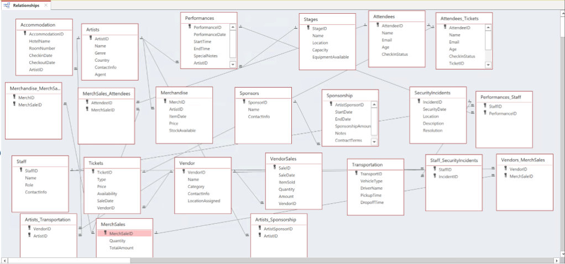

- Adding Data to the Tables using SQL INSERT Statements
Artists
INSERT INTO Artists VALUES (1, 'Luna', 'Pop', 'USA', 'luna@example.com', 'StarTalent Agency')
INSERT INTO Artists VALUES (2, 'Kai', 'Rock', 'Japan', 'kai@example.jp', 'Infinity Music')
INSERT INTO Artists VALUES (3, 'Emma', 'Electronic', 'Canada', 'emma.li@example.ca', 'Northern Sound Mgmt')
Merchandise
INSERT INTO Merchandise VALUES (1, #01-10#, 25.99, 120, 1);
INSERT INTO Merchandise VALUES (2, #02-05#, 39.50, 80, 2);
INSERT INTO Merchandise VALUES (3, #03-12#, 15.00, 200, 3);
MerchSales
INSERT INTO MerchSales VALUES (1, 2, 51.98);
INSERT INTO MerchSales VALUES (2, 1, 39.50);
INSERT INTO MerchSales VALUES (3, 5, 75.00);
Merchandise_MerchSales
INSERT INTO Merchandise_MerchSales VALUES (1, 1);
INSERT INTO Merchandise_MerchSales VALUES (2, 2);
INSERT INTO Merchandise_MerchSales VALUES (3, 3);

Attendees
INSERT INTO Attendees VALUES (1, 'Alice', 'alice@example.com', 25, 'CheckedIn');
INSERT INTO Attendees VALUES (2, 'Brian', 'brian.@example.com', 30, 'NotCheckedIn');
INSERT INTO Attendees VALUES (3, 'Chloe', 'chloe@example.com', 22, 'CheckedIn');

MerchSales_Attendees
INSERT INTO MerchSales_Attendees VALUES (1, 1);
INSERT INTO MerchSales_Attendees VALUES (2, 2);
INSERT INTO MerchSales_Attendees VALUES (3, 3);

Attendees_Tickets
INSERT INTO Attendees_Tickets VALUES (1, 'Alice', 'alice@example.com', 25, 'CheckedIn', 101, 'VIP', 150.00, 'Available', #01-15#);
INSERT INTO Attendees_Tickets VALUES (2, 'Brian', 'brian@example.com', 30, 'NotCheckedIn', 102, 'General', 85.00, 'SoldOut', #01-20#);
INSERT INTO Attendees_Tickets VALUES (3, 'Chloe', 'chloe@example.com', 22, 'CheckedIn', 103, 'VIP', 150.00, 'Available', #01-25#);

Tickets
INSERT INTO Tickets VALUES (101, 'VIP', 150.00, 'Available', #01-15#, 1);
INSERT INTO Tickets VALUES (102, 'General', 85.00, 'SoldOut', #01-20#, 2);
INSERT INTO Tickets VALUES (103, 'VIP', 150.00, 'Available', #01-25#, 3);

Vendors
INSERT INTO Vendors VALUES (1, 'FreshBite Foods', 'Snacks', 'contact@freshbite.com', 'Section A');
INSERT INTO Vendors VALUES (2, 'GlowGear', 'Merchandise', 'info@glowgear.com', 'Section B');
INSERT INTO Vendors VALUES (3, 'DrinkWave', 'Beverages', 'support@drinkwave.com', 'Section C');

VendorSales
INSERT INTO VendorSales VALUES (1, #01-10#, 'Glow Sticks Pack', 20, 199.80, 2);
INSERT INTO VendorSales VALUES (2, #01-12#, 'Bottled Water', 50, 125.00, 3);
INSERT INTO VendorSales VALUES (3, #01-15#, 'Snack Box', 15, 89.25, 1);

Vendors_MerchSales
INSERT INTO Vendors_MerchSales VALUES (1, 1);
INSERT INTO Vendors_MerchSales VALUES (2, 2);
INSERT INTO Vendors_MerchSales VALUES (3, 3);

Transportation
INSERT INTO Transportation VALUES (1, 'Van', 'John', #01-10 14:00#, #01-10 14:45#);
INSERT INTO Transportation VALUES (2, 'SUV', 'Angela', #01-11 09:30#, #-01-11 10:15#);
INSERT INTO Transportation VALUES (3, 'Shuttle Bus', 'David', #01-12 16:00#, #01-12 17:10#);

Artists_Transportation
INSERT INTO Artists_Transportation VALUES (1, 1);
INSERT INTO Artists_Transportation VALUES (2, 2);
INSERT INTO Artists_Transportation VALUES (3, 3);

Sponsorship
INSERT INTO Sponsorship VALUES (1, #01-01#, #06-01#, 50000.00, 'Annual sponsorship', 'Standard contract terms apply', 1);
INSERT INTO Sponsorship VALUES (2, #02-01#, #07-01#, 75000.00, 'Tour partnership', 'Includes promotional rights', 2);
INSERT INTO Sponsorship VALUES (3, #03-15#, #09-15#, 30000.00, 'Event-specific sponsor', 'Limited-term contract', 3);

Sponsors
INSERT INTO Sponsors VALUES (1, 'NovaCorp', 'contact@novacorp.com');
INSERT INTO Sponsors VALUES (2, 'Skyline Media', 'info@skylinemedia.com');
INSERT INTO Sponsors VALUES (3, 'PulseTech', 'support@pulsetech.com');

Artists_Sponsorship
INSERT INTO Artists_Sponsorship VALUES (1, 1);
INSERT INTO Artists_Sponsorship VALUES (2, 2);
INSERT INTO Artists_Sponsorship VALUES (3, 3);

Performances
INSERT INTO Performances VALUES (1, #01-10#, '18:00', '20:00', 'Opening act', 1, 1, 120.00, 300, 'Pop');
INSERT INTO Performances VALUES (2, #01-15#, '20:30', '22:00', 'Main event', 2, 2, 200.00, 500, 'Rock');
INSERT INTO Performances VALUES (3, #01-20#, '19:00', '21:00', 'Evening show', 3, 3, 180.00, 400, 'Jazz');

Stages
INSERT INTO Stages VALUES (1, 'Main Stage', 'North Wing', 1000, 'Lights, Speakers', 'John ', '14:00', #01-05#);
INSERT INTO Stages VALUES (2, 'Side Stage', 'South Wing', 500, 'Basic Sound', 'Jane ', '12:00', #01-07#);
INSERT INTO Stages VALUES (3, 'Acoustic Stage', 'East Wing', 300, 'Acoustic Setup', 'Mike ', '13:00', #01-09#);

Staff
INSERT INTO Staff VALUES (1, 'Alice Brown', 'Usher', 'alice.staff@example.com', '09:00', '17:00', 'Bob Brown');
INSERT INTO Staff VALUES (2, 'Brian Green', 'Technician', 'brian.staff@example.com', '10:00', '18:00', 'Mary Green');
INSERT INTO Staff VALUES (3, 'Chloe White', 'Security', 'chloe.staff@example.com', '08:00', '16:00', 'Tom White');
Performances_Staff
INSERT INTO Performances_Staff VALUES (1, 1, 'Usher', #01-10 17:30#, #01-10 20:30#);
INSERT INTO Performances_Staff VALUES (2, 2, 'Sound Tech', #01-15 19:00#, #01-15 22:30#);
INSERT INTO Performances_Staff VALUES (3, 3, 'Security', #01-20 18:30#, #01-20 21:30#);

SecurityIncidents
INSERT INTO SecurityIncidents VALUES (1, #01-11#, 'Main Stage', 'Lost wallet reported', 'Resolved', 3, 'Medium', #01-12#);
INSERT INTO SecurityIncidents VALUES (2, #01-16#, 'Side Stage', 'Unauthorized entry', 'Resolved', 3, 'High', #01-17#);
INSERT INTO SecurityIncidents VALUES (3, #01-21#, 'Acoustic Stage', 'Spilled drink', 'Cleaned', 2, 'Low', #01-22#);

Staff_SecurityIncidents
INSERT INTO Staff_SecurityIncidents VALUES (1, 1, 'Responding Officer', '17:45', 'Handled quickly');
INSERT INTO Staff_SecurityIncidents VALUES (3, 2, 'Security Lead', '20:15', 'Escorted out');
INSERT INTO Staff_SecurityIncidents VALUES (2, 3, 'Cleaner', '19:30', 'Cleaned area');
Accommodation
INSERT INTO Accommodation VALUES (1, 'Grand Hotel', '101', #01-09#, #01-12#, 1, 'GH-202501', 2, 'Near elevator');
INSERT INTO Accommodation VALUES (2, 'City Inn', '202', #01-14#, #01-17#, 2, 'CI-202501', 1, 'Late check-in');
INSERT INTO Accommodation VALUES (3, 'Sunset Suites', '303', #01-19#, #01-22#, 3, 'SS-202501', 3, 'High floor');

Application Implementation
Scenario 1 – Performance Schedule by Artist and Stage
The event manager wants to see the full performance schedule: which artist is playing, at what time, and on which stage.
SQL query
SELECT a.Name AS ArtistName, p.PerformanceDate, p.StartTime, p.EndTime, s.Name AS StageName, s.Location
FROM (Artists AS a INNER JOIN Performances AS p
ON a.ArtistID = p.ArtistID)
INNER JOIN Stages AS s
ON p.StageID = s.StageID
ORDER BY p.PerformanceDate, p.StartTime;
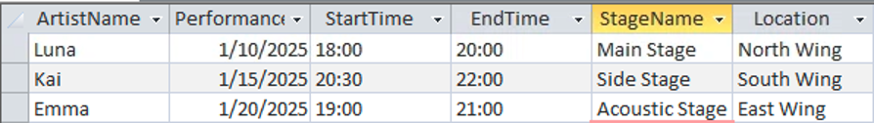
Explanation
This query joins Artists, Performances, and Stages to show a readable performance schedule. Management can quickly see who is performing where and when, which is useful for scheduling and resolving conflicts.

Scenario 2 – Tickets Purchased by Each Attendee
The ticketing team wants to know which attendee bought which type of ticket, and when it was purchased.
SQL query

SELECT atd.Name AS AttendeeName, atd.Email, t.Type AS TicketType, t.Price, t.SaleDate, atd.CheckInStatus
FROM (Attendees AS atd
INNER JOIN Attendees_Tickets AS atk
ON atd.AttendeeID = atk.AttendeeID)
INNER JOIN Tickets AS t
ON atk.TicketID = t.TicketID
ORDER BY t.SaleDate;
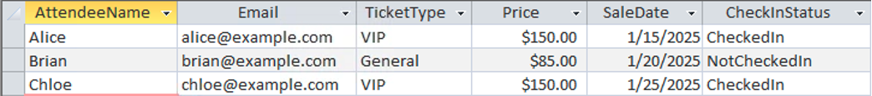
Explanation

This query links Attendees, Attendees_Tickets, and Tickets to show each attendee’s ticket type, price, purchase date, and check-in status. It can be used at the help desk to verify purchases or analyze VIP vs General ticket usage.

Scenario 3 – Total Sales by Vendor
The finance team wants to know which vendors generated the most revenue during the festival.
SQL query
SELECT v.Name AS VendorName,SUM(vs.Amount) AS TotalSales, COUNT(vs.SaleID) AS NumberOfTransactions
FROM Vendors AS v
INNER JOIN VendorSales AS vs
ON v.VendorID = vs.VendorID
GROUP BY v.Name
ORDER BY TotalSales DESC;
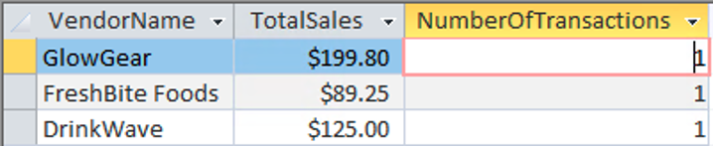
Explanation

This query aggregates VendorSales by vendor, computing total revenue and number of sales per vendor. It helps management decide which vendors to invite back next year and how to negotiate future contracts.

Scenario 4 – Merchandise Revenue by Artist
Business question
The organizers want to see which artists generate the most merchandise revenue.
SQL query
SELECT a.Name AS ArtistName, SUM(ms.TotalAmount) AS TotalMerchRevenue
FROM (((Artists AS a
INNER JOIN Merchandise AS m
ON a.ArtistID = m.ArtistID)
INNER JOIN Merchandise_MerchSales AS mm
ON m.MerchID = mm.MerchID)
INNER JOIN MerchSales AS ms
ON mm.MerchSaleID = ms.MerchSaleID)
GROUP BY a.Name
ORDER BY TotalMerchRevenue DESC;
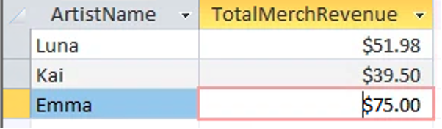

Explanation

This query joins Artists → Merchandise → Merchandise_MerchSales → MerchSales and sums merchandise revenue per artist. It shows which artists sell the most merch and can support decisions about future booking fees or promotional support.

Scenario 5 – Artist Logistics: Accommodation and Transportation
Business question
The logistics team wants one view that shows where each artist is staying and what transportation is assigned to them.
SQL query
SELECT a.Name AS ArtistName,ac.HotelName, ac.RoomNumber,ac.CheckinDate,ac.CheckoutDate,tr.VehicleType,tr.DriverName,tr.PickupTime,tr.DropoffTime
FROM (((Artists AS a
LEFT JOIN Accommodation AS ac
ON a.ArtistID = ac.ArtistID)
LEFT JOIN Artists_Transportation AS at
ON a.ArtistID = at.ArtistID)
LEFT JOIN Transportation AS tr
ON at.TransportID = tr.TransportID)
ORDER BY a.Name;
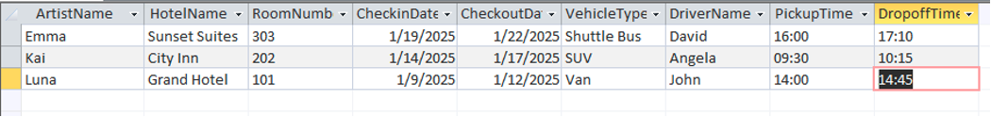
Explanation

This query uses LEFT JOINs so artists are shown even if they are missing hotel or transport records. It combines Artists, Accommodation, Artists_Transportation, and Transportation into one report, helping the logistics team avoid mistakes (like forgetting to book a shuttle for an artist).

Scenario 6 – Security Incidents and Responsible Staff
Business question
Security management wants to review each incident and see which staff members handled it.
SQL query
SELECT si.IncidentID, si.SecurityDate, si.Location,si.Description, si.Resolution, st.Name AS StaffName, st.Role
FROM (SecurityIncidents AS si
INNER JOIN Staff_SecurityIncidents AS ssi
ON si.IncidentID = ssi.IncidentID)
INNER JOIN Staff AS st
ON ssi.StaffID = st.StaffID
ORDER BY si.SecurityDate, si.IncidentID;
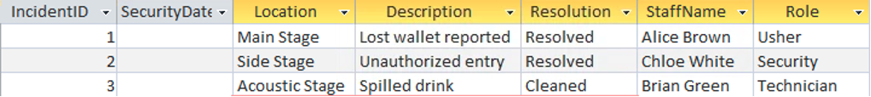
Explanation
This query joins SecurityIncidents, Staff_SecurityIncidents, and Staff to show which staff members were involved in resolving each incident. It’s useful for accountability, training, and improving security procedures.

Conclusion and Reflection

This project gave our group valuable hands-on experience in designing and implementing a relational database system for a real world scenario. Overall, the most challenging part of the project was identifying functional dependencies and properly normalizing the database. With many entities and relationships involved, especially those with many-to-many relationships. It required careful thought to determine how data should be structured and decomposed to avoid redundancy and maintain data integrity.
Once the data model and normalization were completed, implementing the database using SQL was one of the easier steps. Having a clear ERD and a well-normalized schema made it much easier to write the SQL DDL statements and define primary and foreign key constraints. Developing the application scenarios was also manageable, as the normalized design allowed us to write meaningful queries that addressed realistic business questions.
Through this project, we learned how important proper planning is in database design. One thing we did not fully anticipate at the beginning was how much time and attention normalization would require. We also learned that small mistakes in early design decisions can lead to larger issues later on. If we were to complete this project again, we would finalize the ERD business rules earlier and validate the normalized schema against the SQL implementation before inserting sample data, ensuring that the final schema and implementation are fully consistent.
The proposed benefits of the Music Festival Management System can realistically be achieved with the implemented design. By centralizing information related to artists, performances, attendees, vendors, sponsorships, and logistics, the system helps reduce scheduling conflicts, improves organization and supports data driven decision making. The use of primary and foreign key constraints ensures data consistency and reliability, making the system suitable for future expansion.
In conclusion, this project demonstrated how database concepts can be applied to solve real world problems. The Music Festival Management System provides an effective and organized solution for managing complex festival operations.

